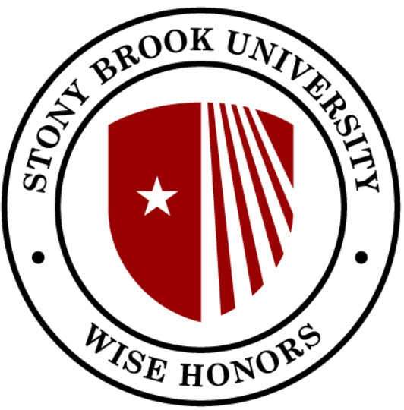
WISE Curriculum
& Stony Brook Curriculum (SBC) Checklist

ARTS
CER → WSE 495: WISE Honors Project/Thesis I (partially); WSE 496: WISE Honors Project/Thesis II (partially)
DIV → WSE 201: Society and Gender in STEM
ESI → WSE 495: WISE Honors Project/Thesis I (partially); WSE 496: WISE Honors Project/Thesis II (partially)
EXP+ → WSE 276: University Honors Fellows Practicum; WSE 487: Research Practicum; WSE: 488: Internship Practicum; WSE 495: WISE Honors Project/Thesis I (partially); WSE 496: WISE Honors Project/Thesis II (partially)
GLO → WSE 105: Opportunities in STEM and Beyond; WSE 201: Society and Gender in STEM HFA+
HUM → WSE 201: Society and Gender in STEM(partially) LANG
QPS
SBS → WSE 381: Service-Learning in STEM SBS+
SNW
SPK → WSE 495: WISE Honors Project/Thesis I (partially); WSE 496: WISE Honors Project/Thesis II (partially)
STAS → WSE 401: Women's Leadership in STEM STEM+
TECH → WSE 380: Research and Discovery in STEM USA
WRT
WRTD → WSE 495: WISE Honors Project/Thesis I (partially); WSE 496: WISE Honors Project/Thesis II (partially)
★ WSE 101, WSE 205, WSE 275, WSE 405, WSE 475, and WSE 477 does not cover an SBC
★ Senior Project/Thesis - WSE 495/496 → Taken in sequence

